*PySilSub*: A Python software for silent substitution

Joel T. Martin1, Geoff Boynton2, Daniel Baker1 and Alex Wade1, Manuel Spitschan3,4,

1Department of Psychology, The University of York, York, United Kingdom, YO10 5DD

2Department of Psychology, University of Washington, 119A Guthrie Hall Box 351525, Seattle, WA 98195-1525

3Max Planck Institute for Biological Cybernetics, Tübingen, Germany

4TUM Department of Sport and Health Sciences (TUM SG), Technical University of Munich, Munich, Germany

Author Note

Address: Joel T. Martin, Department of Psychology, The University of York, York, United Kingdom, YO10 5DD

Phone: +44 (0)1904 323190

Email: [joel.martin@](mailto:joel.martin@)york.ac.uk

The research was supported by funding from the Biotechnology and Biological Sciences Research Council (BBSRC: BB/V007580/1), the Engineering and Physical Sciences Research Council (EPSRC: EP/S021507/1), the Welcome Trust (204686/Z/16/Z) and John Fell OUP Research Fund, University of Oxford (0005460).

Abstract

A normal human retina contains several classes of photosensitive cell—rods for low-light vision, three types of cones for daylight vision, and the intrinsically photosensitive retinal ganglion cells (ipRGCs) expressing melanopsin for controlling non-image-forming functions (e.g., pupil size, circadian rhythms). The spectral sensitivities of the photoreceptors overlap significantly, meaning most lights will stimulate all photoreceptors, but to varying degrees. The method of silent substitution provides a principled basis for stimulating individual photoreceptor classes selectively, which is useful in research and clinical settings. The main hardware requirement for silent substitution is a spectrally calibrated light stimulation system with at least as many primaries as there are photoreceptors under consideration. Device settings that will produce lights to selectively stimulate the photoreceptor(s) of interest can be found using a variety of analytic and algorithmic approaches. Here we present *PySilSub*, a novel Python package for silent substitution featuring object-oriented support for individual colorimetric observer models, multi-primary stimulation devices, and solving silent substitution problems with linear algebra and constrained numerical optimisation. The software is registered with the Python Package Index and includes example data sets from various multi-primary systems. We hope that *PySilSub* will further encourage the application of silent substitution in research and clinical settings.

Keywords: silent substitution, melanopsin, instrumentation, pupillary light reflex, software, open source

*PySilSub:* A Python toolbox for performing the method of silent substitution with multiprimary stimulation devices.

A normal human retina contains several types of photosensetive cell (for review, see Grünert & Martin, 2020). Enabling colour and spatial vision at mesopic and photopic light levels are the short-, medium-, and long-wavelength-light-sensetive cone photoreceptors. Cone cells are packed densley into the fovea and distributed more sparsely elsewhere in retinae. For scotopic (twilight) spatial vision we have rod photoreceptors. Though absent from the fovea, rods are most numerous of the photoreceptor cells and are otherwise widely distributed in retinae. Finally, discovered in human retinae only at the turn of the millenium—intrinsically photosensetive retinal ganglion cells (ipRGCs) expressing the photopigment melanopsin in their axons and soma (Provencio et al., 2000). ipRGCs do not contribute to vision in the same way as rods and cones but they do play important roles in ‘non-visual’ functions, such as circadian photoentraiment and pupil control, via direct projections to the suprachiasmatic nucleus of the hypothalamus and the olivary pretectal nucleus of the midbrain (Gamlin et al., 2007; Ruby et al., 2002).

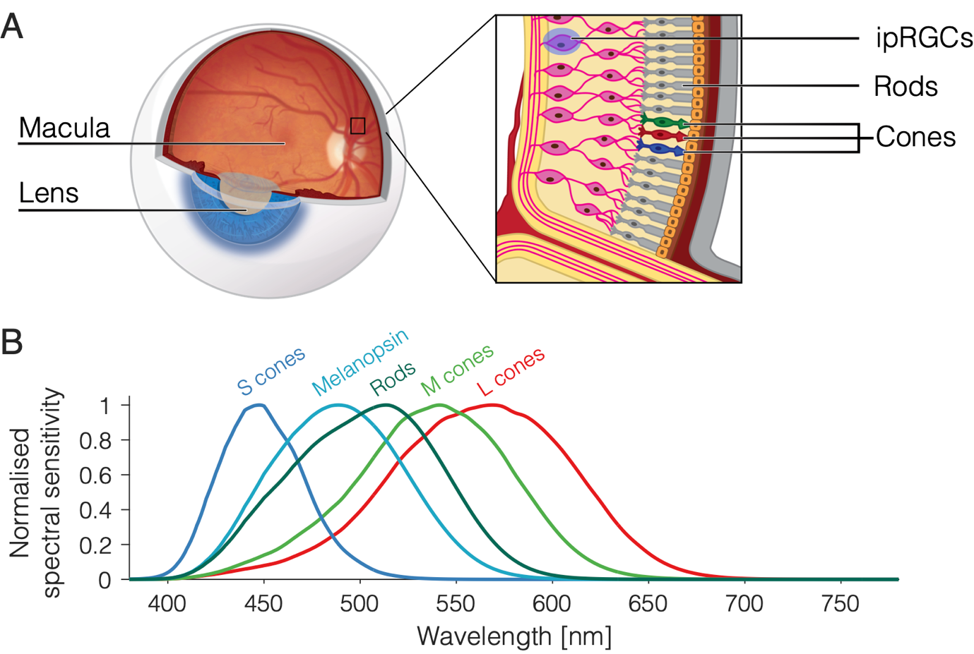

Figure 1. Photoreceptors and their spectral sensitivities. (A) Human eye with inset showing the three types of retinal photoreceptor: rods, cones, and intrinsically photosensitive retinal ganglion cells (ipRGCs). (B) Overlapping spectral sensitivities of retinal photoreceptors. The curve for each photoreceptor describes the probability of photon capture at a given wavelength.

As illustrated in Figure 1, the photoreceptors have different spectral sensitivities. The curve for each type of photoreceptor describes the probability of its capturing a photon at a given wavelength, so S-cones are about 10 times more likely than L-cones to capture photons at 450 nm, and the liklihood of L- and M-cones capturing at 550 nm is about the same. Because the spectral sensetivities of the photoreceptors overlap, it should be clear that most lights in the visible spectrum will stimulate all types of photoreceptor, albeit to varying degrees. However, it is possible to prepare light stimuli that selectively target photoreceptor classes via the method of silent substitution.

Silent substitution is an elegant technique that involves using a multiprimary stimulation system to produce pairs of lights that selectively stimulate one class of retinal photoreceptor whilst maintaining a constant level of activation in the others. This is possible owing to Rushton’s (1972) principle of univariance, which states that the output of a photoreceptor is one-dimensional and depends upon quantum catch, not upon what quanta are caught. In other words, different light spectra will have an identical effect on a photoreceptor providing they lead to the same number of photons being absorbed. The prinicple of univariance and its relevance to silent substitution is covered in greater detail by Estévez and Spekreijse (1982) along with other details regarding the early history of the method. In vision science, silent substitution has contributed to our understanding of human colour vision mechanisms (Horiguchi et al., 2013) and it has enabled researchers to examine how targeted photoreceptor stimulation affects physiological responses such as melatonin suppression (Allen et al., 2018), the electroretinogram (Maguire et al., 2017), and the pupillary light reflex (Spitschan et al., 2014). Its potential as a diagnostic tool for retinal disease has also garnered attention in recent years (Kuze et al., 2017; Wise et al., 2021).

To perform silent substitution, one must acquire a suitable multiprimary stimulation system with accurate calibration spectra for each of its individual primaries and the photoreceptor action spectra for the intended observer (see below). By interpolating the calibration spectra one can predict the spectral output for any combination of input settings and quantify it in terms of photoreceptor activation by computing a weighted integral:

$$w=\int_{λ_{1}}^{λ_{2}}{E\left(λ\right)V\left(λ\right)d}$$

where $λ_{1}$ and $λ_{2}$ define the wavelength range, $E\left(λ\right)$ is the measured light spectrum (radiance or irradiance, in photons or watts), $V\left(λ\right)$ is the estimated photoreceptor sensitivity function, and $d$ is the size of the wavelength bins. By convention (CIE, 2018; Lucas et al., 2014), when this operation concerns the spectral sensitivity functions of retinal photoreceptors, the resulting measures may be called *α*-opic irradiance, where *α* denotes the opsin-based photopigment of one of the five photoreceptors (cyanolabe, chlorolabe, erythrolabe, rhodopsin and melanopsin). The process of calculating *α*-opic irradiance is illustrated in Figure 2.

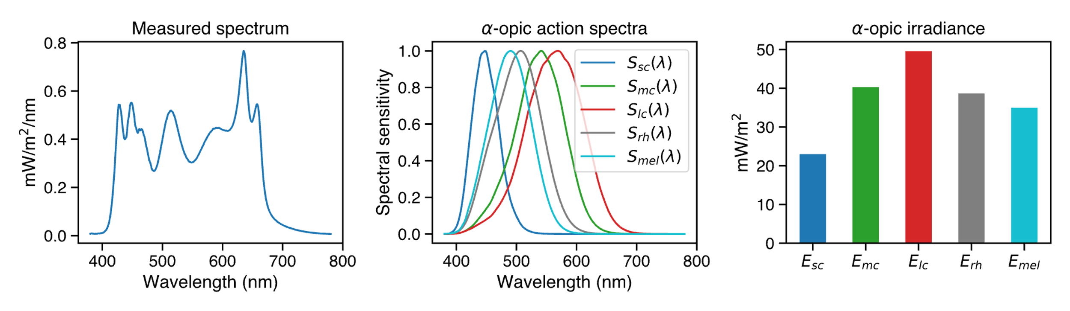

Figure 2. Converting a spectrum to α-opic irradiance. The equation here is $E_{α}=\sum_{380}^{780}{E\left(λ\right)S_{α}\left(λ\right)Δ}$.

The goal of silent substitution is then to find the device input settings for two spectra—a background spectrum and a modulation spectrum—where the resulting *α*-opic quantities will be the same for all but the targeted photoreceptor(s). This process is typically accomplished with computational approaches based on linear algebra (e.g., Cao et al., 2015; Maguire et al., 2016; Shapiro et al., 1996) or constrained numerical optimisation (e.g., Spitschan et al., 2015), but it is encumbered by confounds that must be addrsessed in order that a solution be valid. These confounds pertain chiefly to calibration procedures, stimulus geometry, ocular physiology (particularly individual differences therein), and uncertainty as to the output and reliability of the stimulation device (Spitschan & Woelders, 2018).

In this paper we present *PySilSub*, a Python toolbox that eases the computational burden of silent substitution by taking a structured approach to dealing with the various confounds and challenges. The toolbox provides flexible object-oriented support for multiprimary stimulation devices and individual colorimetric observer models, example calibration data for a range of devices, an intuitive interface for defining and solving silent substitution problems with linear algebra and constrained numerical optimization, and methods for accessing relevant standards and visualising solutions. The code is actively maintained on GitHub (<https://github.com/PySilentSubstitution/pysilsub>) under the MIT license and comes with a comprehensive testing suite and extensive online documentation, complete with detailed examples. It is also registered with the Python Package Index ([https://pypi.org/project/pysilsub/)](https://pypi.org/project/pysilsub/) meaning it can be installed with the *pip* packaing tool. We provide an overview of the toolbox, describe key features, and demonstrate how it can be used.

**Overview**

*PySilSub* is written in Python and depends on widely used libraries for scientiffic computing (e.g., numpy, scipy, pandas, matplotlib). It has three key modules to support colorimetric observer models (observers.py), stimulation devices (devices.py), and defining and solving silent substitution problems (problems.py). Additional supporting modules provide quick and easy access to CIE standards (CIE.py), prereceptoral filters (precep.py) and color-related functions (colorfuncs.py). Figure 3 lays out the anatomy of the *PySilSub* package and highlites some of the main features.



Figure 3. This will be much better.

**Colorimetric observers**

Human colour vision differs between individuals. This is most notable in the case of colour vision abnormalities such as dichromacy (only two cones are functional) and anomalous trichromacy (at least one cone has abnormal spectral tuning), but subtle differences also exist in colour-normal individuals due to variations in ocular physiology. Before striking the retina, incident light must first travel through the lens and macula pigment of the observer, which act as prereceptoral filters to effectively shift the spectral sensitivity of the underlying photoreceptors. The crystalline lens accumulates its yellow pigment with age due to absorption of near-UV radiation (Norren & Vos, 1974; Pokorny et al., 1987; Weale, 1988) and a yellower lens admits less short-wavelength light (Figure 3, A-B). The macula pigment is a yellow carotenoid spot that sits above foveal photoreceptors and reduces the spectral sensitivity of underlying cones in a manner that becomes more pronounced at smaller stimulus field sizes (Chen et al., 2001; Whitehead et al., 2006). Together, observer age and stimulus field size combine to alter the effective spectral sensitivity functions of a given observer under particular viewing conditions (Figure 5, A-B).

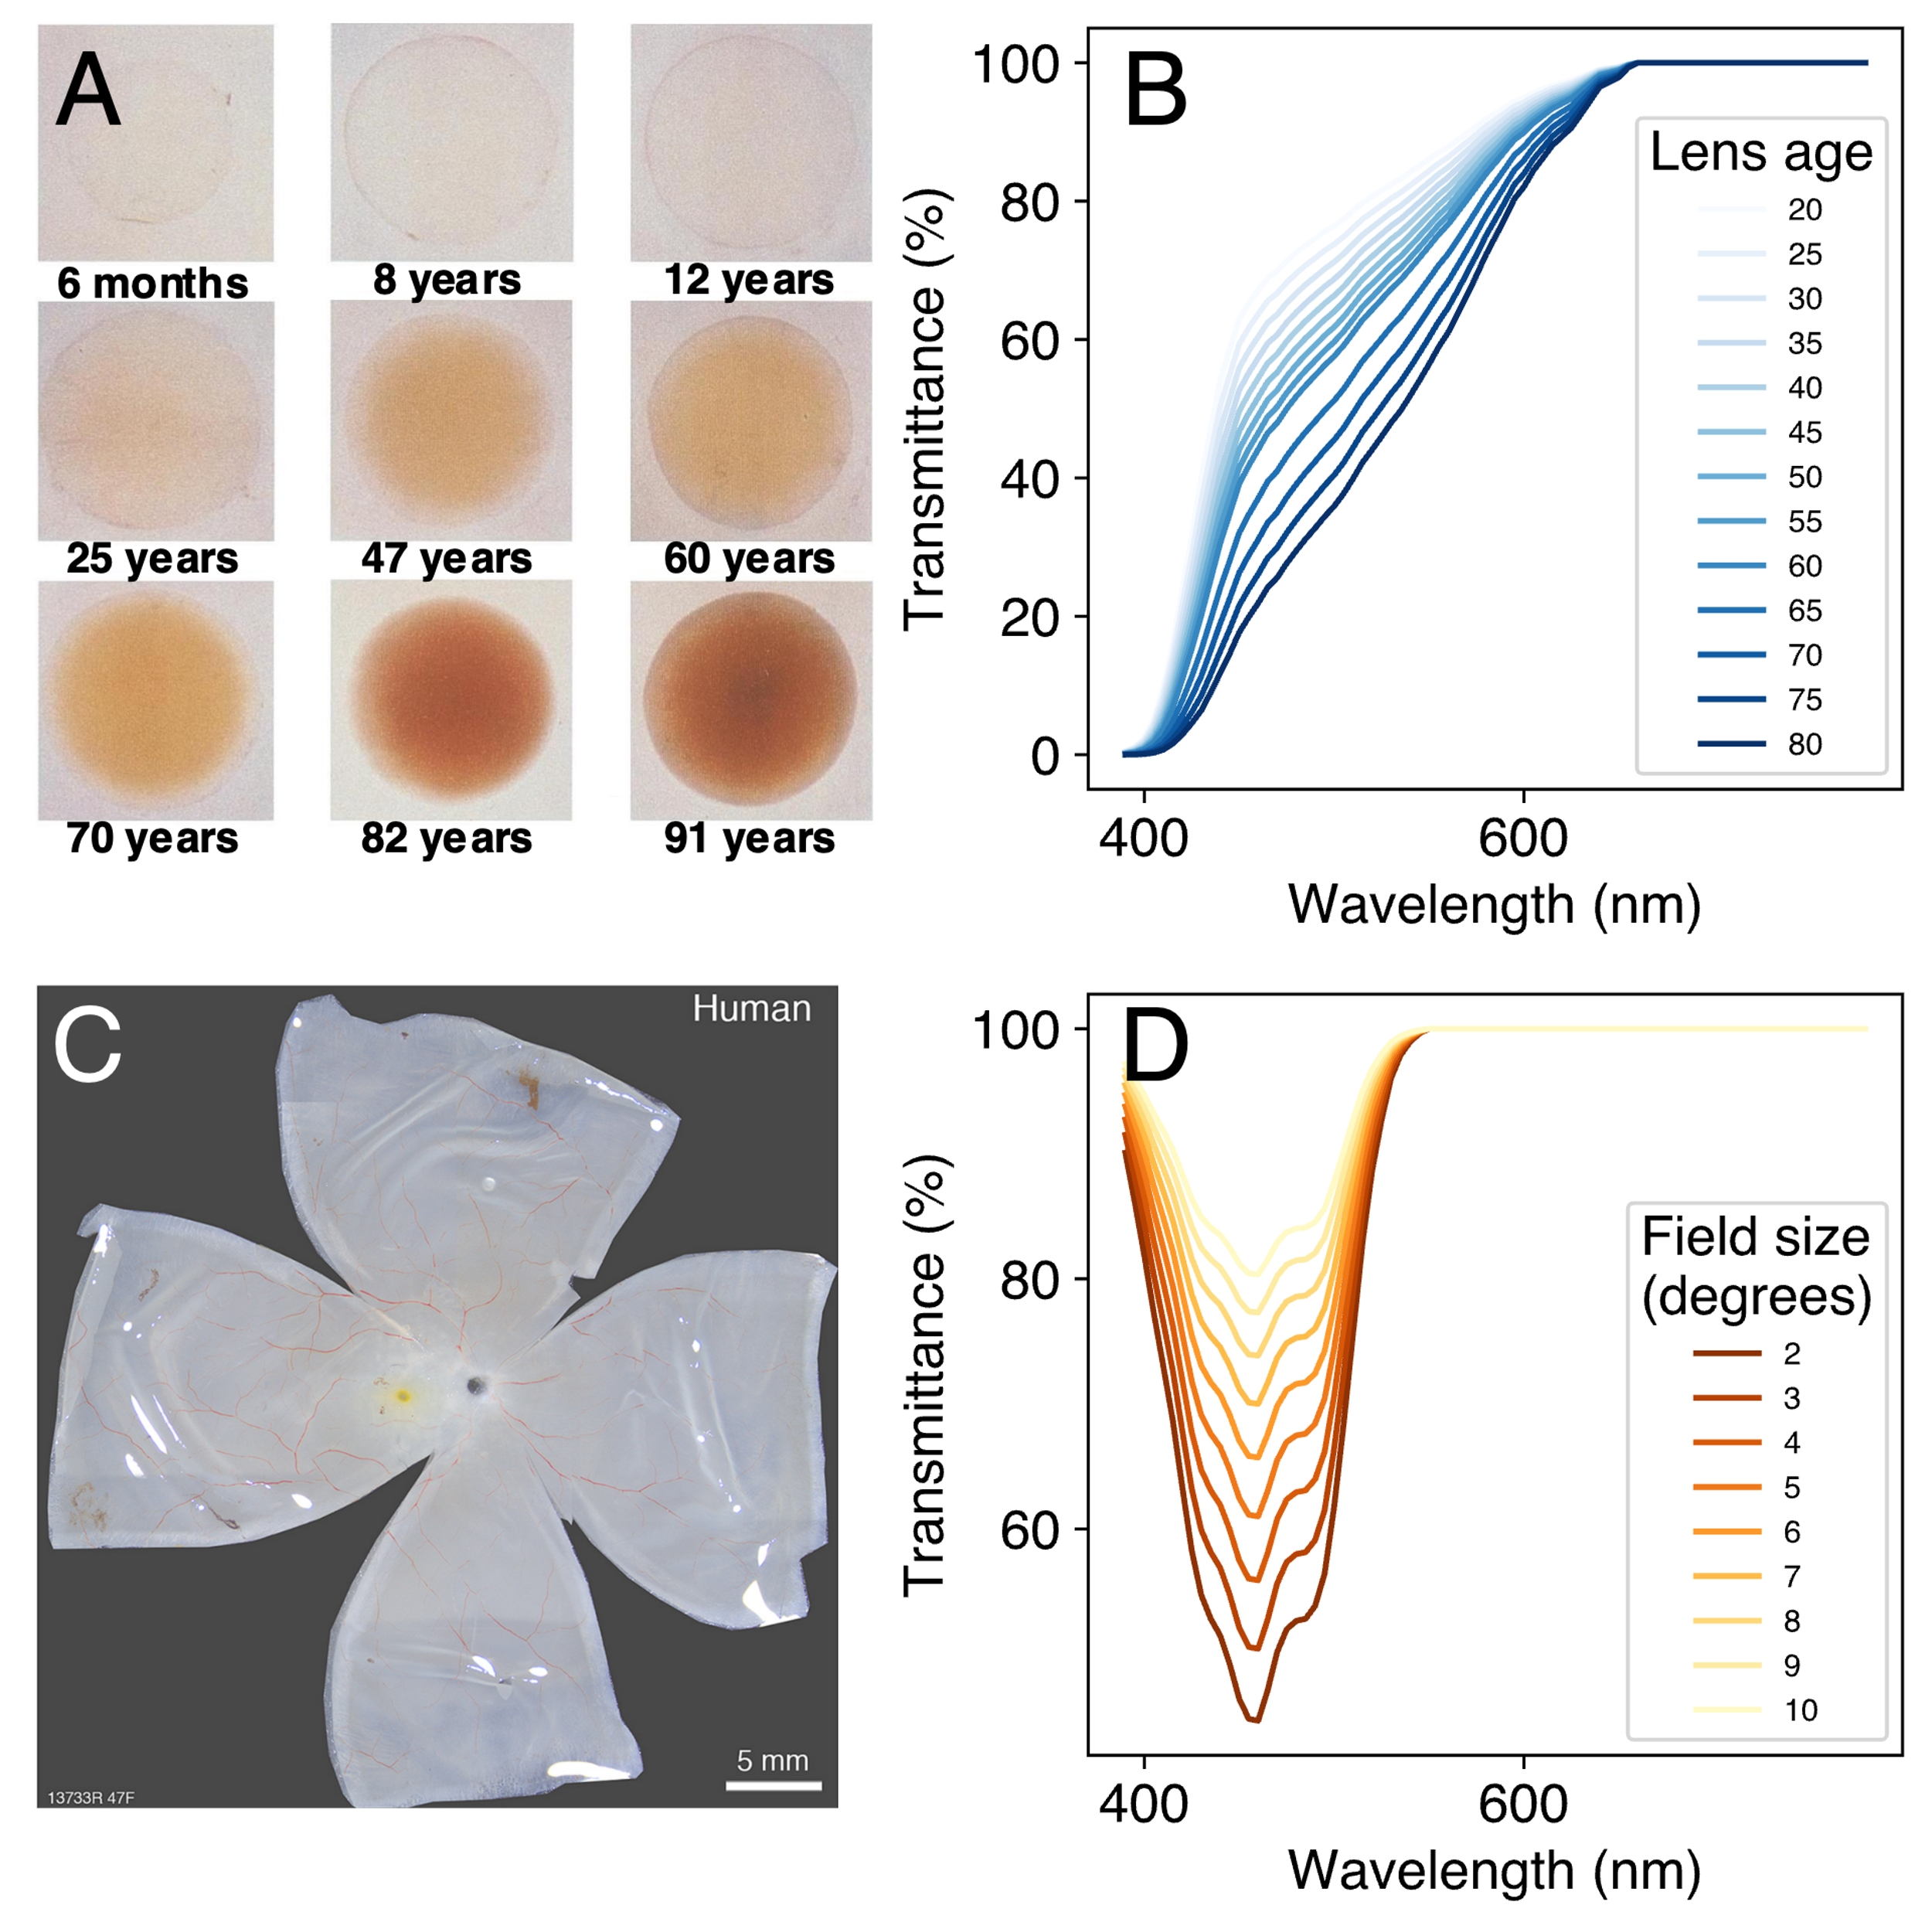

Figure 4. Prereceptoral filtering of light by ocular media. (A) The human lens naturally accumulates a yellow pigment with age due to absorption of near-UV radiation ([SOURCE](https://eyewiki.aao.org/File:Cataract_nuclear_changes.jpg)). (B) Spectral transmittance functions of the lens for ages 20-80, showing that older lenses transmit less light. (C) Excised human retina with the macula pigment visible as a yellow spot at the position of the fovea (Grünert & Martin, 2020). (D) Spectral transmittance as a function of stimulus field size. Prereceptoral filtering by the macula pigment is greater at smaller field sizes. All transmittance functions were calculated in accordance with CIE 170-1:2006.

The International Commission on Illumination (CIE) define average colorimetric observer models with estimates of photoreceptor spectral sensitivities for a given age and field size. The CIE standards are based on decades of research involving predominantly psychophysical methods (Smith & Pokorny, 1975; Stiles & Burch, 1959; Stockman et al., 1993, 1999; Stockman & Sharpe, 2000; Vos & Walraven, 1970) but also techniques such as suction electrode recording and microspectrophotometry of photoreceptors (e.g., Baylor et al., 1984; Bowmaker et al., 1978; Bowmaker & Dartnall, 1980). The CIE 2006 Physiological Observer standard (CIEPO06: CIE, 2006) defines fundamental spectral sensitivity functions for 2° and 10° field sizes and outlines a framework for calculating average spectral sensitivity functions for any age between 20 and 80 years and any field size between 1° and 10°. More recently, inspired by the pioneering research into melanopsin-containing ipRGCs (e.g., Al Enezi et al., 2011; Berson et al., 2002; Brown et al., 2013; Dacey et al., 2005; Gamlin et al., 2007; Lucas et al., 2014; Provencio et al., 2000), the CIE released another standard (CIES026: CIE, 2018) describing the melanopic action spectrum and outlining best practices for documenting photoreceptor responses to light.

*PySilSub* consolidates the above standards in a ColorimetricObserver class that internally computes photoreceptor action spectra for a given age and field size. LMS cone fundamentals are constructed from the photopigment absorbance spectra, taking account of the peak axial density of the respective photopigments, as well as lens and macular pigment density, in accordance with CIEPO06 (CIE, 2006). The melanopic and rhodopic action spectra of the 32-year-old standard observer are taken from CIES026 (CIE, 2018) and adjusted for lens density with a spectral correction function, in accordance with the standard. Note that, for consistency with the melanopic research tradition, a slightly different lens density function is used to correct the melanopic and rhodopic action spectra (see CIE S026/E:2018 for more info). Macular pigment correction is not applied in these cases as rods are not present at the fovea and ipRGCs are positioned above the retinal pigment layer. The ColorimetricObserver class stores the photoreceptor action spectra in a *pandas* *DataFrame* and seamlessly interacts with other parts of the toolbox, making it easy to prepare silent substitution stimuli for any field size between 1° and 10° and for any observer aged between 20 and 80 years. A further advantage of this approach is that it enables the toolbox to be flexibly adapted to special cases. For example, one may wish wish to perform silent substitution with non-human animals (e.g., see Allen & Lucas, 2016; Josh W. Mouland et al., 2021; Joshua W. Mouland et al., 2019; Wise et al., 2021), in which case one need only create a modified observer class with the relevant action spectra (see examples online).

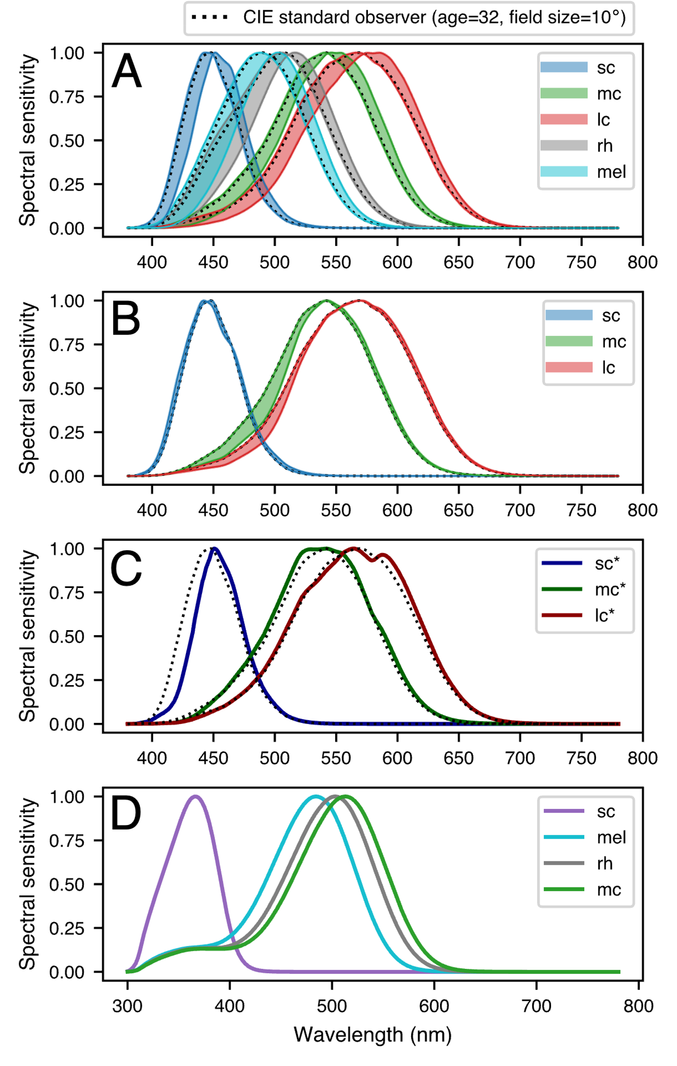

Figure 5. Spectral sensitivity of photoreceptors depends on the ocular physiology of the observer. (A) Lens yellowing with age causes a rightward shift in peak sensitivity of the photopigments and alters the overall shape of the sensitivity functions (shaded areas show the range of the spectral shift for ages 20-80 years). (B) Decreasing stimulus field size causes a small shift in S-cone sensitivity and a marked dampening of the left-hand slopes of the sensitivity functions for M- and L-cones (shaded areas show the range of the spectral shift for field sizes 10° to 2°). Note that the effects of macular pigment absorption are considered negligible for rhodopsin and melanopsin, as rods are absent from the fovea and ipRGCs sit above the retinal pigment layer. (C) Cones in the shadow of retinal blood vessels (sc*, mc*, lc*) have altered spectral sensitivity functions due to prefiltering of light by blood (Spitschan et al., 2015). (D) Spectral sensitivity functions are species dependent. The example shown is for mice. Note that mice do not possess a third cone and that the spectral sensitivity of photoreceptors peaks at different locations in the visual spectrum in comparison to humans. S-cone sensitivity is shifted leftwards towards the near-UV portion of the spectrum and there is increased overlap of the M-cone, melanopic and rhodopic action spectra.

**Multiprimary stimulation devices**

To perform silent substitution, requires a stimulation system with at least as many primaries as there are photoreceptors in the retina. This generally means that 5 primaries are needed, although 4 primaries may suffice when working in the photopic range as rods become saturated and incapable of signaling above 300 cd/m2 (Adelson, 1982; Aguilar & Stiles, 1954; but see Kremers et al., 2009; Shapiro, 2002; Sharpe et al., 1989). The primaries should be independently addressable, additive, and ideally stable over time with a linear input-output function. Peak wavelength and bandwidth of the primaries are key considerations that will define the gamut and available contrast (Evéquoz et al., 2021), and the light source will need to be integrated into an optical setup for stimulus delivery—usually either a Ganzfeld (e.g., Martin et al., 2021) or Maxwellian (e.g., Cao et al., 2015; Nugent & Zele, 2022). Reviewing the stimulation devices from a range of silent substitution studies, Conus and Geiser (2020) found that in most cases the device had 4 or 5 primaries and was built from scratch using LEDs, optical bench components, and microprocessors (e.g., Arduino) for pulse width modulation control of intensity.

*PySilSub* supports multiprimariy stimulation devices through a generic *StimulationDevice* class that turns a set of spectral calibration measurements into a forward model. The required format of the calibration data is a CSV file where the first row describes the wavelength sampling (e.g., 380, 381, … 780) and every other row is a spectral measurement (see Table 1). Also required in the CSV file are the column headers *Primary* and *Setting*, with corresponding values to identify the spectral measurements. For a perfectly linear device it would suffice to measure each channel at maximum and minimum, but as devices tend not to be linear it is prudent to obtain measurements across the input range. If sampling with an OceanOptics (﻿Ocean Insight Inc., Oxford, UK) or JETI ﻿(JETI Technische Instrumente, GmbH, Jena, Germany) spectrometer, one may benefit from the interfaces in python packages such as *LuxPy* (Smet, 2020), *PyPlr* (Martin et al., 2021; Martin & Spitschan, 2021) or *Seabreeze* (Poehlmann, 2019).

Table 1. Calibration file format for StimulationDevice. Minimal example is shown for a hypothetical 4-primary device. Each primary is marked with an ordinal index starting at zero and has a spectral measurement for the maximum (255) and minimum (0) input setting, where the minimum setting should reflect the ambient spectral power distribution (i.e., when all channels are off). A reasonable number of intermediary measurements should also be included to account for non-linearity.

|  |  |  |  |  |  |  |
| --- | --- | --- | --- | --- | --- | --- |
| Wavelength | | 380 | 381 | … | 779 | 780 |
| Primary | Setting |
| 0 | 0 | *Spectral measurements -->* | | | | |
| 0 | … |
| 0 | 255 |
| 1 | 0 |
| 1 | … |
| 1 | 255 |
| 2 | 0 |
| 2 | … |
| 2 | 255 |
| 3 | 0 |
| 3 | … |
| 3 | 255 |

StimulationDevice has various methods for predicting and visualizing the spectral and colorimetric output of a device. The basis of all forward-predictions is a method called .predict_primary_spd() which uses linear interpolation on the calibration spectra to predict the spectral output for a given primary at a given setting. A similar function called .predict_multiprimary_spd() simply calls the previous function for a sequence of device primary inputs and sums the resulting spectra. All predictive methods respond to native device settings or floating-point input weights between 0.0 and 1.0. Additional methods make it easy to change back and forth between weights and settings.

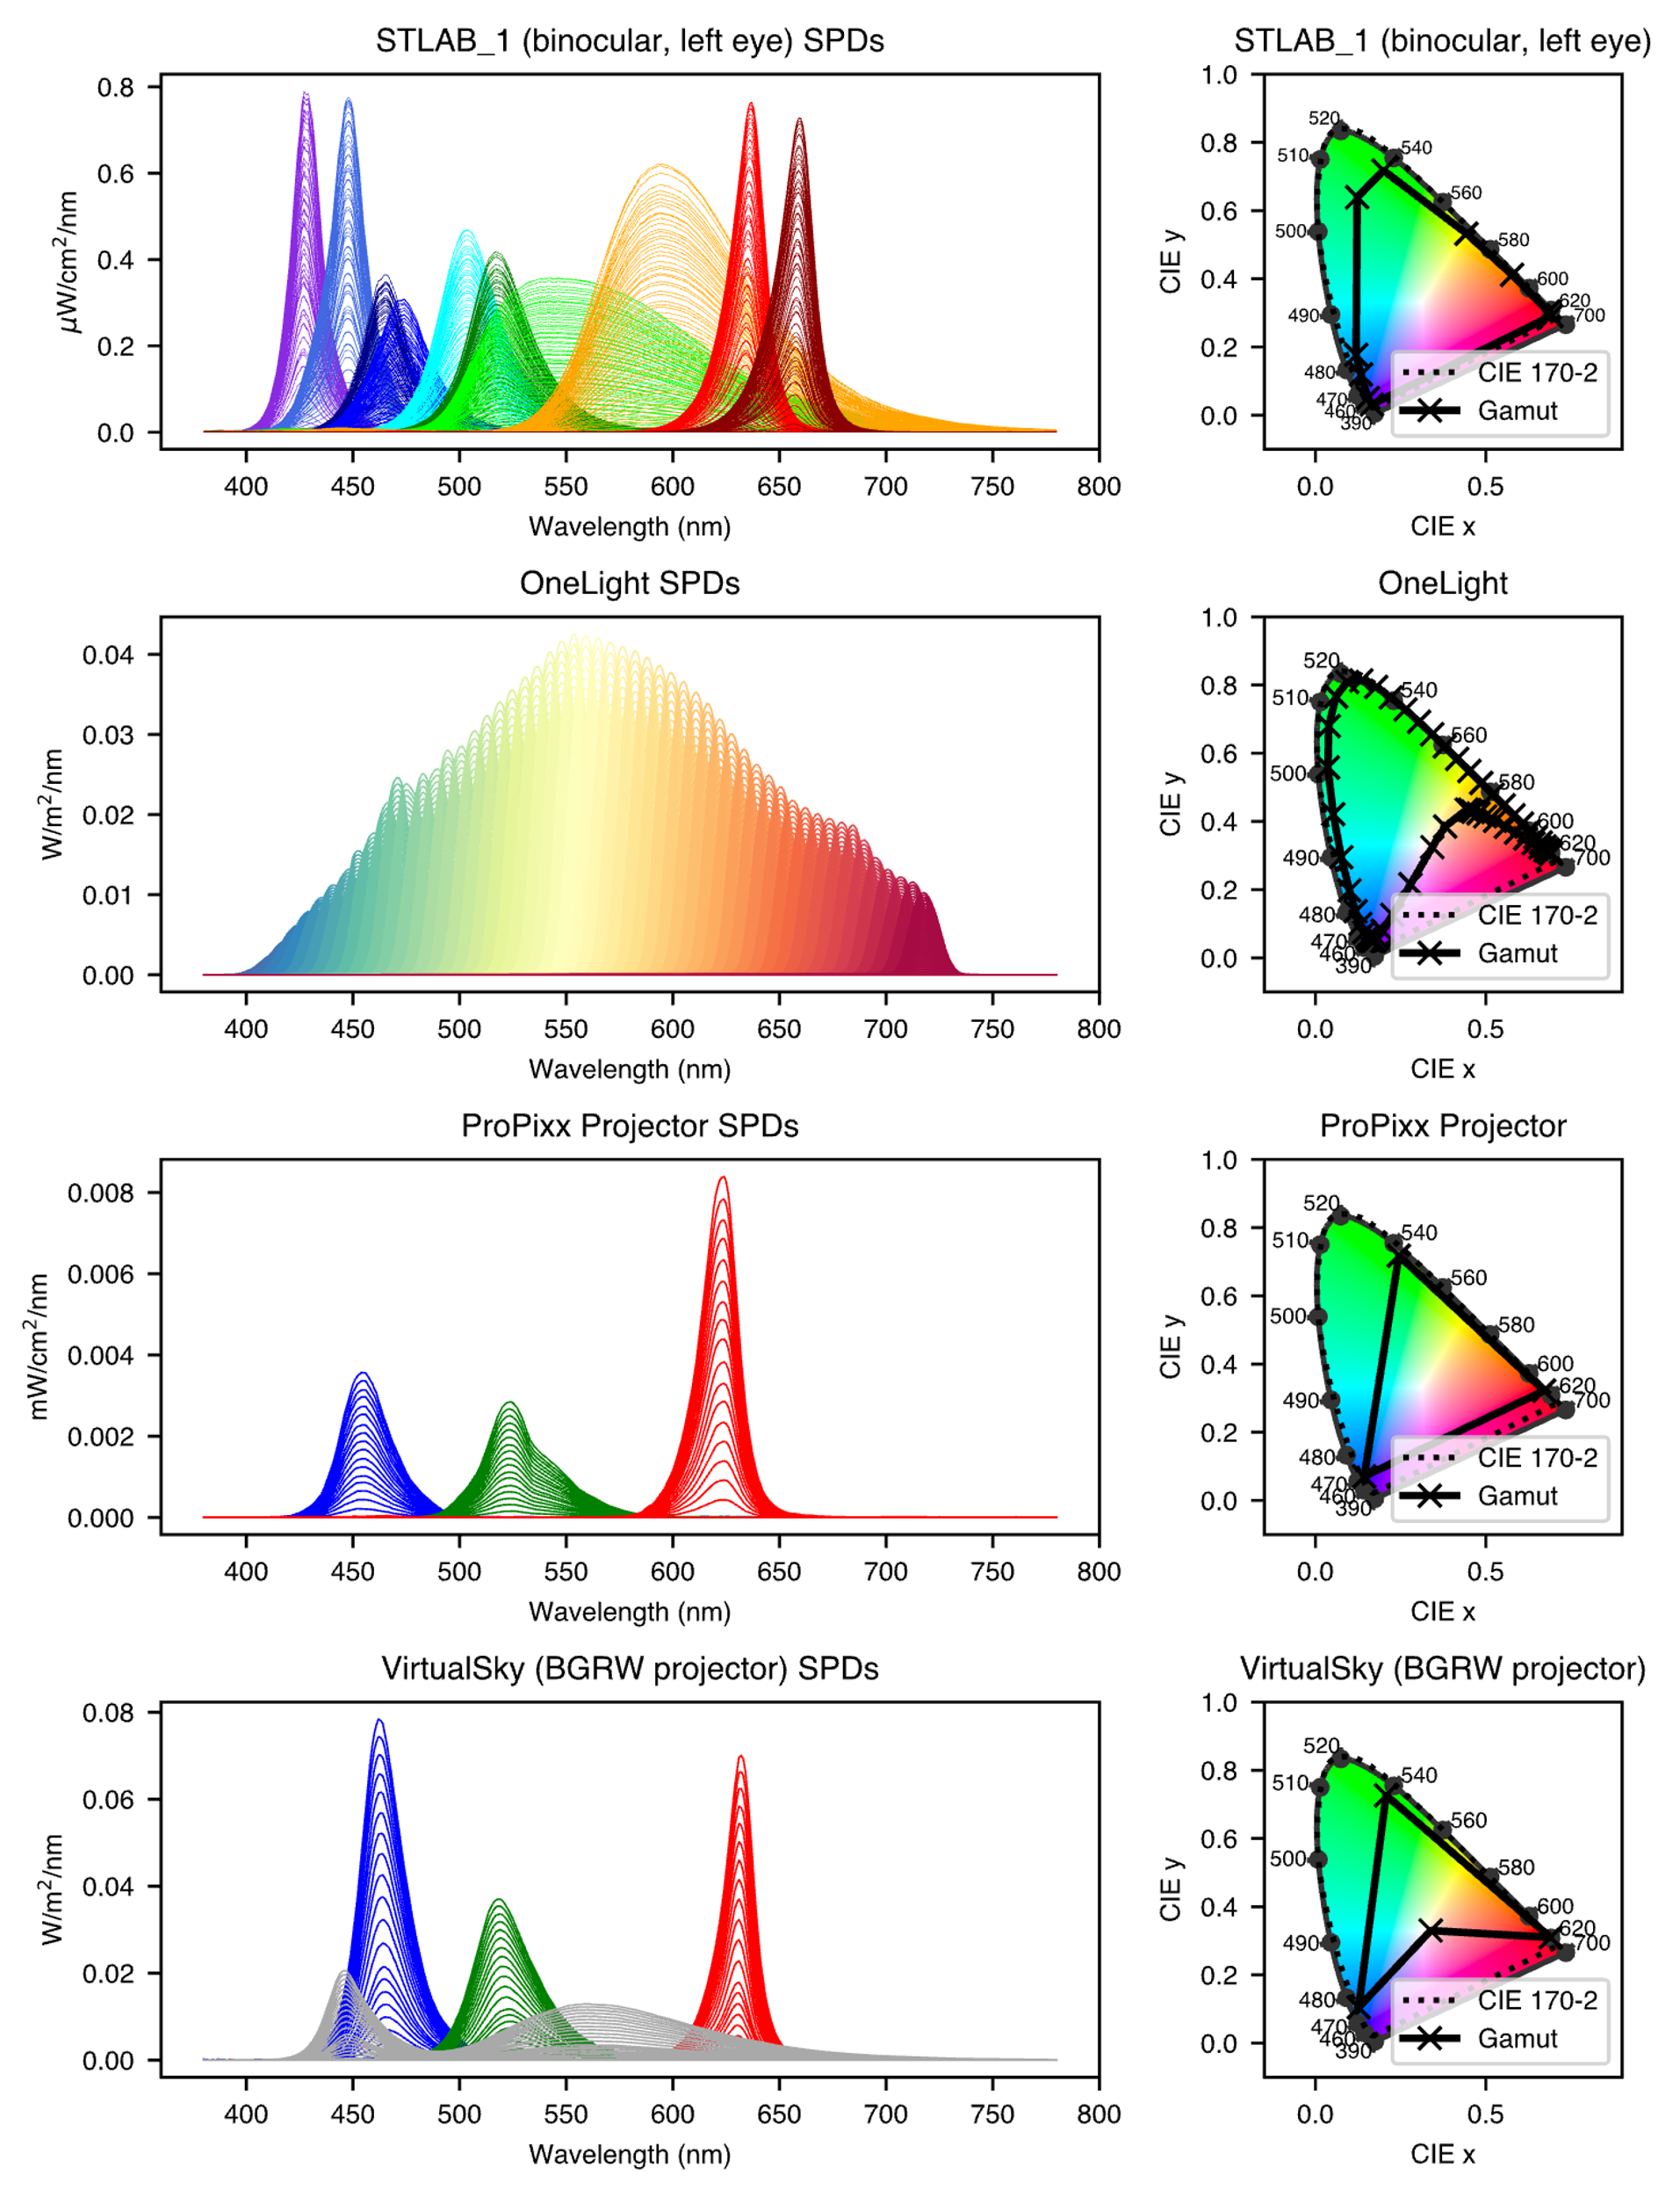

Figure 6. PySilSub comes with package data for a range of multiprimary stimulation devices.

**Silent substitution problems**

Silent substitution stimuli typically take the form of pulses or temporal modulations of photoreceptor-specific contrast presented against a background spectrum to which an observer has adapted. The background spectrum serves to maintain a set pattern of photoreceptor activations and the modulation spectrum increases activation of the targeted photoreceptor(s) without altering activation of the others.

The nature of a silent substitution problem depends on the research question, but there Sometimes it is desirable to aim for a particular amount of contrast, and one may also wish to ignore some photoreceptors. To account for

PySilSub has a SilentSubstitutionProblem class to serve as an interface for defining and solving silent substitution problems. The background spectrum, target contrast, and which receptors to ignore, minimize and modulate are defined as properties

, silent substitution problems are conditioned by defining the background spectrum, target contrast, and photoreceptors to ignore, minimize (silence) and modulate as class properties (i.e., managed attributes) which interact with the solvers and other class methods. This design pattern, though non-standard in a Pythonic sense, is fit for purpose as it is intuitive and saves having many functions which take lots of arguments.

* Non-standard though intuitive design pattern where the background spectrum, target contrast, and the photoreceptors to ignore, minimize and modulate are defined as properties (i.e. managed attributes) of the silent substitution problem, which internally condition the problem and interact with the solver methods.
* Error handling
* Ignore a cone (e.g., Huchzermeyer et al., 2018; Kremers et al., 1999; Usui et al., 1998)

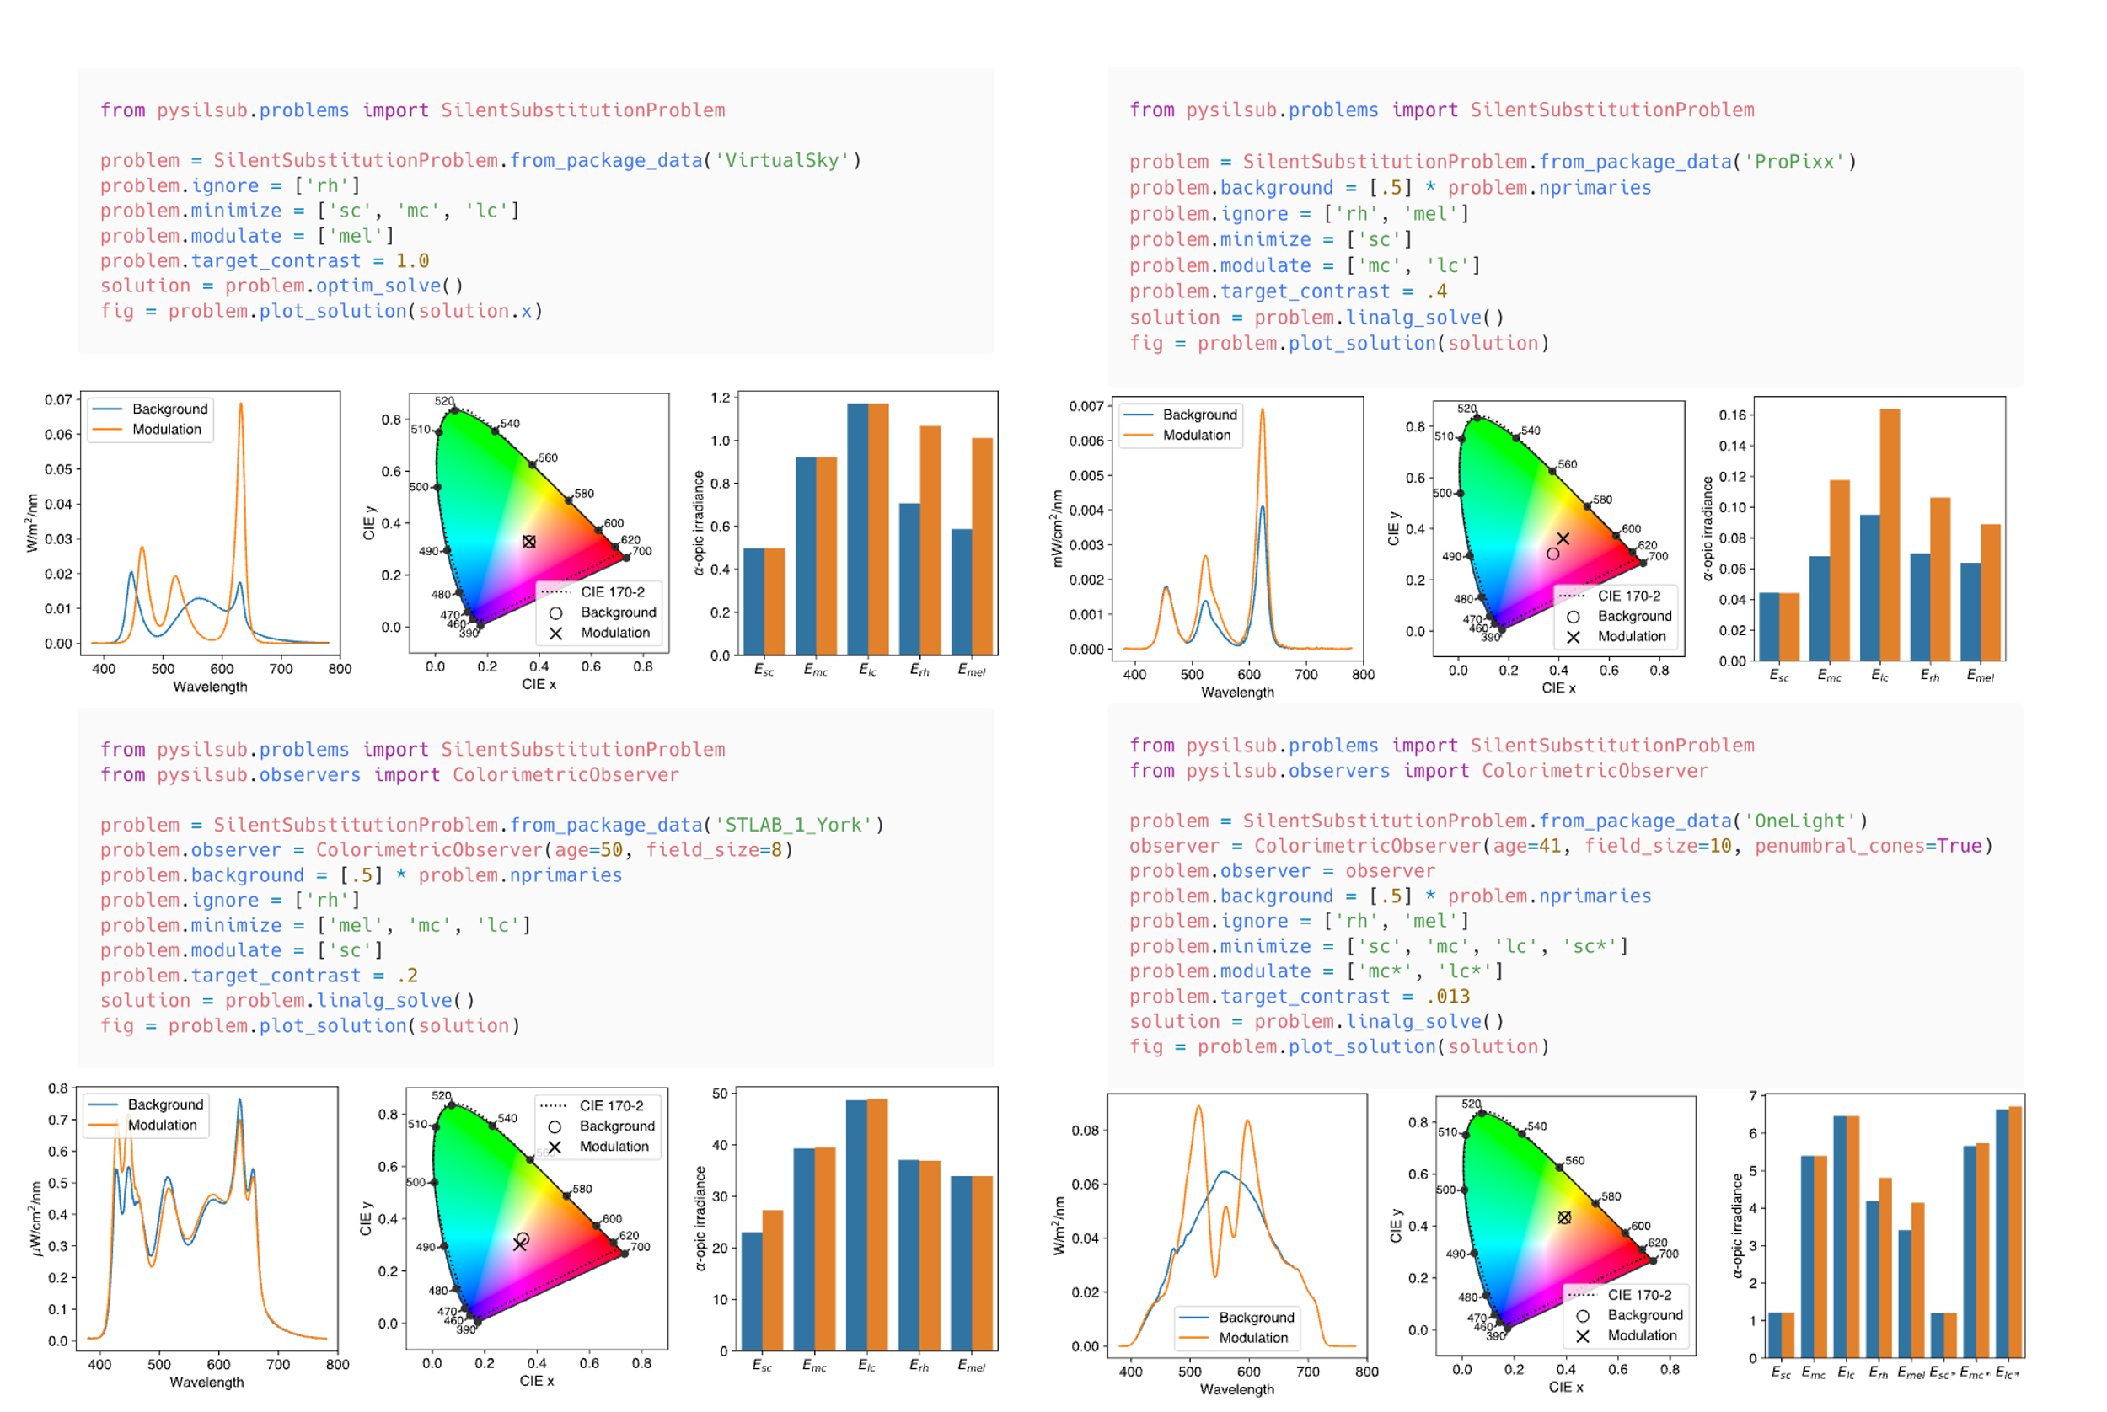

***Numerical optimization.***

Silent substitution can be approached as a constrained numerical optimization problem of the form:

Where are the optimization variables (the device settings) whose lower and upper bounds, and , are between 0 and 1 to ensure that the solution is within the gamut of the device, is the objective function that aims to maximise contrast of the target photoreceptor(s), and is a function that calculates contrast for the silenced photoreceptor(s), where and should be zero. In all cases, is a vector containing the weights for the LED settings.

***Linear algebra.***

***Binocular silent substitution.***

**Discussion**

This paper described *PySilSub*, a novel Python software for silent substitution. In summary, *PySilSub* consolidates CIE standards, turns the calibration spectra for a multiprimary stimulation device into a predictive model, and provides an intuitive interface for defining and solving silent substitution problems.

As we have noted, our software takes a structured approach to the challenges and confounds of silent substitution by consolidating relevant standards, but it does not resolve all potential issues with the method. This is because some of them come from biological factors that are not well understood, such as the potential bi- and tri-stability of the melopsin photopigment. Also, (Kamar et al., 2019) – silent substitution silences light signals but not ouput. As a consequence, it is important to take care when interpreting the result of a silent substitution experiment.

Asside from silent substitution, PySilSub is a convenient

**Summary**

**Acknowledgements**

References

Adelson, E. H. (1982). Saturation and Adaptation. *Vision Research*, *22*, 1299–1312.

Aguilar, M., & Stiles, W. S. (1954). Saturation of the rod mechanism of the retina at high levels of stimulation. *Optica Acta: International Journal of Optics*, *1*(1), 59–65. https://doi.org/10.1080/713818657

Al Enezi, J., Revell, V., Brown, T., Wynne, J., Schlangen, L., & Lucas, R. J. (2011). A “melanopic” spectral efficiency function predicts the sensitivity of melanopsin photoreceptors to polychromatic lights. *Journal of Biological Rhythms*, *26*(4), 314–323. https://doi.org/10.1177/0748730411409719

Allen, A. E., Hazelhoff, E. M., Martial, F. P., Cajochen, C., & Lucas, R. J. (2018). Exploiting metamerism to regulate the impact of a visual display on alertness and melatonin suppression independent of visual appearance. *Sleep*, *41*(8), 1–7. https://doi.org/10.1093/sleep/zsy100

Allen, A. E., & Lucas, R. J. (2016). Using silent substitution to track the mesopic transition from rod- to cone-based vision in mice. *Investigative Ophthalmology and Visual Science*, *57*(1), 276–287. https://doi.org/10.1167/iovs.15-18197

Baylor, D. A., Nunn, B. J., & Schnapf, J. L. (1984). The photocurrent, noise and spectral sensitivity of rods of the monkey Macaca fascicularis. *The Journal of Physiology*, *357*(1), 575–607. https://doi.org/10.1113/jphysiol.1984.sp015518

Berson, D. M., Dunn, F. A., & Takao, M. (2002). Phototransduction by retinal ganglion cells that set the circadian clock. *Science*, *295*(5557), 1070–1073. https://doi.org/10.1126/science.1067262

Bowmaker, J. K., & Dartnall, H. J. (1980). Visual pigments of rods and cones in a human retina. *The Journal of Physiology*, *298*(1), 501–511. https://doi.org/10.1113/jphysiol.1980.sp013097

Bowmaker, J. K., Dartnall, H. J., Lythgoe, J. N., & Mollon, J. D. (1978). The visual pigments of rods and cones in the rhesus monkey, Macaca mulatta. *The Journal of Physiology*, *274*(1), 329–348. https://doi.org/10.1113/jphysiol.1978.sp012151

Brown, T. M., Allen, A. E., Al-Enezi, J., Wynne, J., Schlangen, L., Hommes, V., & Lucas, R. J. (2013). The melanopic sensitivity function accounts for melanopsin-driven responses in mice under diverse lighting conditions. *PLoS ONE*, *8*(1), 1–8. https://doi.org/10.1371/journal.pone.0053583

Cao, D., Nicandro, N., & Barrionuevo, P. A. (2015). A five-primary photostimulator suitable for studying intrinsically photosensitive retinal ganglion cell functions in humans. *Journal of Vision*, *15*(1), 1–13. https://doi.org/10.1167/15.1.27

Chen, S. F., Chang, Y., & Wu, J. C. (2001). The spatial distribution of macular pigment in humans. *Current Eye Research*, *23*(6), 422–434. https://doi.org/10.1076/ceyr.23.6.422.6963

CIE. (2006). Fundamental chromaticity diagram with physiological axes. In *CIE Technical Report*. https://cie.co.at/publications/fundamental-chromaticity-diagram-physiological-axes-part-1

CIE. (2018). *CIE System for Metrology of Optical Radiation for ipRGC-Influenced Responses to Light.* CIE Central Bureau.

Conus, V., & Geiser, M. (2020). A review of silent substitution devices for melanopsin stimulation in humans. *Photonics*, *7*(4), 1–10. https://doi.org/10.3390/photonics7040121

Dacey, D. M., Liao, H. W., Peterson, B. B., Robinson, F. R., Smith, V. C., Pokorny, J., Yau, K. W., & Gamlin, P. D. R. (2005). Melanopsin-expressing ganglion cells in primate retina signal colour and irradiance and project to the LGN. *Nature*, *433*(7027), 749–754. https://doi.org/10.1038/nature03344

Estévez, O., & Spekreijse, H. (1982). The “ Silent Substitution ” method in research. *Vision Research*, *22*(6), 681–691. https://doi.org/10.1016/0042-6989(82)90104-3

Evéquoz, G., Truffer, F., & Geiser, M. (2021). Maximum possible contrast level for silent substitution: a theoretical model applied to melanopsin stimulation. *Journal of the Optical Society of America A*, *38*(9), 1312. https://doi.org/10.1364/josaa.420373

Gamlin, P. D. R., McDougal, D. H., Pokorny, J., Smith, V. C., Yau, K. W., & Dacey, D. M. (2007). Human and macaque pupil responses driven by melanopsin-containing retinal ganglion cells. *Vision Research*, *47*(7), 946–954. https://doi.org/10.1016/j.visres.2006.12.015

Grünert, U., & Martin, P. R. (2020). Cell types and cell circuits in human and non-human primate retina. *Progress in Retinal and Eye Research*, *78*(November 2019), 100844. https://doi.org/10.1016/j.preteyeres.2020.100844

Horiguchi, H., Winawer, J., Dougherty, R. F., & Wandell, B. A. (2013). Human trichromacy revisited. *Proceedings of the National Academy of Sciences of the United States of America*, *110*(3). https://doi.org/10.1073/pnas.1214240110

Huchzermeyer, C., Martins, C. M. G., Nagy, B., Barboni, M. T. S., Ventura, D. F., Costa, M. F., & Kremers, J. (2018). Photoreceptor-specific light adaptation of critical flicker frequency in trichromat and dichromat observers. *Journal of the Optical Society of America A*, *35*(4), B106. https://doi.org/10.1364/josaa.35.00b106

Kamar, S., Howlett, M. H. C., & Kamermans, M. (2019). Silent-substitution stimuli silence the light responses of cones but not their output. *Journal of Vision*, *19*(5), 1–11. https://doi.org/10.1167/19.5.14

Kremers, J., Czop, D., & Link, B. (2009). Rod and S-cone driven ERG signals at high retinal illuminances. *Documenta Ophthalmologica*, *118*(3), 205–216. https://doi.org/10.1007/s10633-008-9159-0

Kremers, J., Usui, T., Scholl, H. P. N., & Sharpe, L. T. (1999). Cone signal contributions to electrograms in dichromats and trichromats. *Investigative Ophthalmology and Visual Science*, *40*(5), 920–930.

Kuze, M., Morita, T., Fukuda, Y., Kondo, M., Tsubota, K., & Ayaki, M. (2017). Electrophysiological responses from intrinsically photosensitive retinal ganglion cells are diminished in glaucoma patients. *Journal of Optometry*, *10*(4), 226–232. https://doi.org/10.1016/j.optom.2016.07.004

Lucas, R. J., Peirson, S. N., Berson, D. M., Brown, T. M., Cooper, H. M., Czeisler, C. A., Figueiro, M. G., Gamlin, P. D., Lockley, S. W., O’Hagan, J. B., Price, L. L. A., Provencio, I., Skene, D. J., & Brainard, G. C. (2014). Measuring and using light in the melanopsin age. *Trends in Neurosciences*, *37*(1), 1–9. https://doi.org/10.1016/j.tins.2013.10.004

Maguire, J., Parry, N. R. A., Kremers, J., Kommanapalli, D., Murray, I. J., & McKeefry, D. J. (2016). Rod electroretinograms elicited by silent substitution stimuli from the light-adapted human eye. *Translational Vision Science and Technology*, *5*(4). https://doi.org/10.1167/tvst.5.4.13

Maguire, J., Parry, N. R. A., Kremers, J., Murray, I. J., & McKeefry, D. (2017). The morphology of human rod ERGs obtained by silent substitution stimulation. *Documenta Ophthalmologica*, *134*(1), 11–24. https://doi.org/10.1007/s10633-017-9571-4

Martin, J. T., Pinto, J., Bulte, D., & Spitschan, M. (2021). PyPlr: A versatile, integrated system of hardware and software for researching the human pupillary light reflex. *Behavior Research Methods*, *0123456789*. https://doi.org/10.3758/s13428-021-01759-3

Martin, J. T., & Spitschan, M. (2021). *PyPlr (v1.0.0) [computer software]*. https://doi.org/https://doi.org/10.5281/zenodo.1234

Mouland, Josh W., Martial, F. P., Lucas, R. J., & Brown, T. M. (2021). Modulations in irradiance directed at melanopsin, but not cone photoreceptors, reliably alter electrophysiological activity in the suprachiasmatic nucleus and circadian behaviour in mice. *Journal of Pineal Research*, *70*(4), 1–12. https://doi.org/10.1111/jpi.12735

Mouland, Joshua W., Martial, F., Watson, A., Lucas, R. J., & Brown, T. M. (2019). Cones Support Alignment to an Inconsistent World by Suppressing Mouse Circadian Responses to the Blue Colors Associated with Twilight. *Current Biology*, *29*(24), 4260-4267.e4. https://doi.org/10.1016/j.cub.2019.10.028

Norren, D. V., & Vos, J. J. (1974). Spectral transmission of the human ocular media. *Vision Research*, *14*(11), 1237–1244. https://doi.org/10.1016/0042-6989(74)90222-3

Nugent, T. W., & Zele, A. J. (2022). A five-primary Maxwellian-view display for independent control of melanopsin , rhodopsin , and three-cone opsins on a fine spatial scale. *Journal of Vision*, *22*, 1–22.

Poehlmann, A. (2019). *Seabreeze (v1.3.0) [computer software]*. https://github.com/ap--/python-seabreeze/releases/tag/v1.3.0

Pokorny, J., Smith, V. C., & Lutze, M. (1987). Aging of the human lens. *Applied Optics*, *26*(8), 1437. https://doi.org/10.1364/ao.26.001437

Provencio, I., Rodriguez, I. R., Jiang, G., Hayes, W. P., Moreira, E. F., & Rollag, M. D. (2000). A novel human opsin in the inner retina. *Journal of Neuroscience*, *20*(2), 600–605. https://doi.org/10.1523/jneurosci.20-02-00600.2000

Rushton, W. A. H. (1972). Pigments and signals in colour vision. *The Journal of Physiology*, *220*(3), 1–31. https://doi.org/10.1113/jphysiol.1972.sp009719

Shapiro, A. G. (2002). Cone-specific mediation of rod sensitivity in trichromatic observers. *Investigative Ophthalmology and Visual Science*, *43*(3), 898–905.

Shapiro, A. G., Pokorny, J., & Smith, V. C. (1996). Cone – rod receptor spaces with illustrations and light-emitting-diode spectra EVALUATION OF ROD EXCITATION. *Journal of the Optical Society of America*, *13*(12), 2319–2328.

Sharpe, L. T., Fach, C., Nordby, K., & Stockman, A. (1989). The incremental threshold of the rod visual system and Weber’s law. *Science*, *244*(4902), 354–356. https://doi.org/10.1126/science.2711186

Smet, K. A. G. (2020). Tutorial: The LuxPy Python Toolbox for Lighting and Color Science. *LEUKOS - Journal of Illuminating Engineering Society of North America*, *16*(3), 179–201. https://doi.org/10.1080/15502724.2018.1518717

Smith, V. C., & Pokorny, J. (1975). Spectral sensitivity of the foveal cone photopigments between 400 and 500 nm. *Vision Research*, *15*(2), 161–171. https://doi.org/10.1016/0042-6989(75)90203-5

Spitschan, M., Aguirre, G. K., & Brainard, D. H. (2015). Selective stimulation of penumbral cones reveals perception in the shadow of retinal blood vessels. *PLoS ONE*, *10*(4), 1–22. https://doi.org/10.1371/journal.pone.0124328

Spitschan, M., Jain, S., Brainard, D. H., & Aguirre, G. K. (2014). Opponent melanopsin and S-cone signals in the human pupillary light response. *Proceedings of the National Academy of Sciences of the United States of America*, *111*(43), 15568–15572. https://doi.org/10.1073/pnas.1400942111

Spitschan, M., & Woelders, T. (2018). The method of silent substitution for examining melanopsin contributions to pupil control. *Frontiers in Neurology*, *9*(NOV). https://doi.org/10.3389/fneur.2018.00941

Stiles, W. S., & Burch, J. M. (1959). N.P.L. Colour-matching investigation: Final report (1958). *Optica Acta: International Journal of Optics*, *6*(1), 1–26. https://doi.org/10.1080/713826267

Stockman, A., MacLeod, D. I. A., & Johnson, N. E. (1993). Spectral sensitivities of the human cones. *Journal of the Optical Society of America A*, *10*(12), 2491. https://doi.org/10.1364/josaa.10.002491

Stockman, A., & Sharpe, L. T. (2000). The spectral sensitivities of the middle- and long-wavelength-sensitive cones derived from measurements in observers of known genotype. *Vision Research*, *40*(13), 1711–1737. https://doi.org/10.1016/S0042-6989(00)00021-3

Stockman, A., Sharpe, L. T., & Fach, C. (1999). The spectral sensitivity of the human short-wavelength sensitive cones derived from thresholds and color matches. *Vision Research*, *39*(17), 2901–2927. https://doi.org/10.1016/S0042-6989(98)00225-9

Usui, T., Kremers, J., Sharpe, L. T., & Zrenner, E. (1998). Flicker cone electroretinogram in dichromats and trichromats. *Vision Research*, *38*, 3391–3396.

Vos, J. J., & Walraven, P. L. (1970). On the derivation of the foveal receptor primaries. *Vision Research*, *11*(2), 799–818.

Weale, R. A. (1988). Age and the transmittance of the human crystalline lens. *The Journal of Physiology*, *395*(1), 577–587. https://doi.org/10.1113/jphysiol.1988.sp016935

Whitehead, A. J., Mares, J. A., & Danis, R. P. (2006). Macular pigment: A review of current knowledge. *JAMA Ophthalmology*, *124*(7), 1038–1045. https://doi.org/10.1001/archopht.124.7.1038

Wise, E. N., Foster, M. L., Kremers, J., & Mowat, F. M. (2021). A modified silent substitution electroretinography protocol to separate photoreceptor subclass function in lightly sedated dogs. *Veterinary Ophthalmology*, *24*(1), 103–107. https://doi.org/10.1111/vop.12847